**Lauren Pelayo**

**Thomas Lindholm**

**Alex Lundin**

PHYS 2125.104.603

TA: Mathew Fong

Oct. 18, 2015

**Lab 6: Newton’s Second Law**

**Table of Contents**

1. **Analysis**
2. **Plots**
3. **Calculations**
4. **Data Graphs**

1. **Analysis**

**(Q5.1.1)**

**The results we obtained in table 2 deviate slightly from the theory that says all momentum momentum is conserved in collisions. The coefficient of friction on the airtrack and human error when we slid the glider initially could have contributed to the discrepancy.**

**(Q5.1.2)**

**More kinetic energy was conserved in the trials where only one glider was moving. In the second set of  trials, with two gliders in motions, there were more variables and places to loose energy to dissipative forces. Such as heat between the contact points and friction as well.**

**(Q5.1.3)**

**The collisions with a single glider in motion tended to be more elastic because they conserved more kinetic energy. The collisions with two gliders in motion were less elastic since they lost kinetic energy.**

**(Q5.2.1)**

**d,h and alpha labeled below**

**(Q5.2.2)**

**Zero reference of potential energy labeled below**

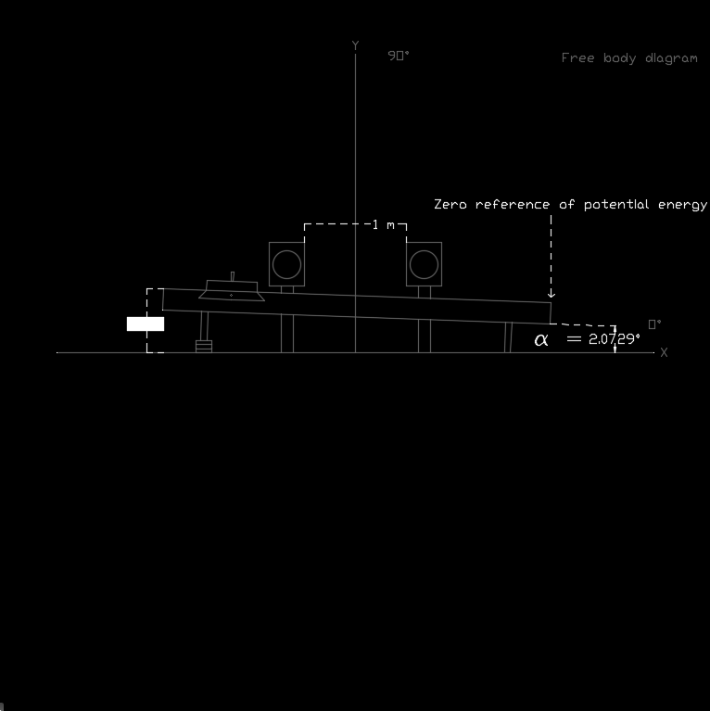

**(Q5.2.3)**

**(Q5.2.4)**

1. **Plots**
2. **Calculations**
3. **Data / Graphs**

|  |  |  |  |  |  |  |  |  |
| --- | --- | --- | --- | --- | --- | --- | --- | --- |
|  | Initial | | | | Final | | | |
| Trial | dir 1 | v1 | dir 2 | v2 | dir 1 | v1 | dir 2 | v2 |
| 1 | + | 0.3734 | / | 0 | / | 0 | + | 0.332 |
| 2 | + | 0.3332 | / | 0 | / | 0 | + | 0.337 |
| 3 | + | 0.3619 | / | 0 | / | 0 | + | 0.324 |
| 4 | + | 0.2172 | - | 0.219 | - | 0.1811 | + | 0.153 |
| 5 | + | 0.2232 | - | 0.16 | - | 0.1342 | + | 0.187 |
| 6 | + | 0.162 | - | 0.253 | - | 0.2178 | + | 0.123 |
| 7 | + | 0.2704 | - | 0.129 | - | 0.1015 | + | 0.229 |
|  |  | m/s |  | m/s |  | m/s |  | m/s |
| Table 1: Data for velocities before and after collisions | | | | | | | | |

|  |  |  |  |  |  |  |  |
| --- | --- | --- | --- | --- | --- | --- | --- |
| Trial | p1 (i) | p2 (i) | p1 (f) | p2 (f) | pt (i) | pt (t) | % d |
| 1 | 0.0687 | 0 | 0 | 0.0618 | 0.0687 | 0.0618 | 10.12 |
| 2 | 0.0611 | 0 | 0 | 0.0627 | 0.0611 | 0.0618 | 2.31 |
| 3 | 0.0666 | 0 | 0 | 0.0602 | 0.0666 | 0.0602 | 9.50 |
| 4 | 0.0399 | 0.0408 | 0.0333 | 0.0285 | 0.0807 | 0.0618 | 23.46 |
| 5 | 0.041 | 0.0298 | 0.0247 | 0.0348 | 0.0708 | 0.0595 | 16.03 |
| 6 | 0.0298 | 0.047 | 0.04 | 0.0229 | 0.0769 | 0.0629 | 18.10 |
| 7 | 0.0498 | 0.024 | 0.0187 | 0.0426 | 0.0737 | 0.0613 | 16.92 |
|  | kg (m/s) | kg (m/s) | kg (m/s) | kg (m/s) | kg (m/s) | kg (m/s) |  |
| Table 2: Data table for momentum analysis of collisions | | | | | | | |
|  | | | | | | | |
| Trial | K1 (i) | K2 (i) | K1 (f) | K2 (f) | Kt (i) | Kt (t) | % d |
| 1 | 0.0128 | 0 | 0 | 0.0102 | 0.0128 | 0.0102 | 20.09 |
| 2 | 0.0101 | 0 | 0 | 0.0105 | 0.0101 | 0.0105 | 4.15 |
| 3 | 0.012 | 0 | 0 | 0.0101 | 0.012 | 0.0101 | 16.46 |
| 4 | 0.00434 | 0.00446 | 0.00302 | 0.00218 | 0.00881 | 0.0052 | 40.98 |
| 5 | 0.00459 | 0.00238 | 0.00166 | 0.00325 | 0.00697 | 0.00491 | 29.51 |
| 6 | 0.00242 | 0.00596 | 0.00437 | 0.01408 | 0.00837 | 0.00577 | 32.03 |
| 7 | 0.00637 | 0.00155 | 0.00095 | 0.00488 | 0.00828 | 0.00583 | 29.60 |
|  | J | J | J | J | J | J |  |
| Table 3: Data table for energy analysis of collisions | | | | | | | |